We have two intergration point in sunshine app like add location so we get weather data and second is communicate with server .

1) When user enter invalid location or lack of server communication so the result in empty data base and that means it retune empty list so we handle and add following things in our code

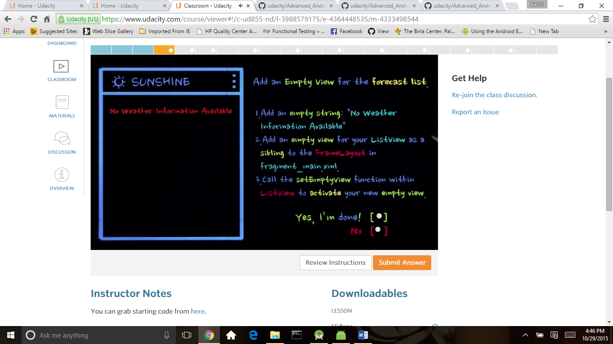

2)Second we check the network connection is proper or not for this we do following things

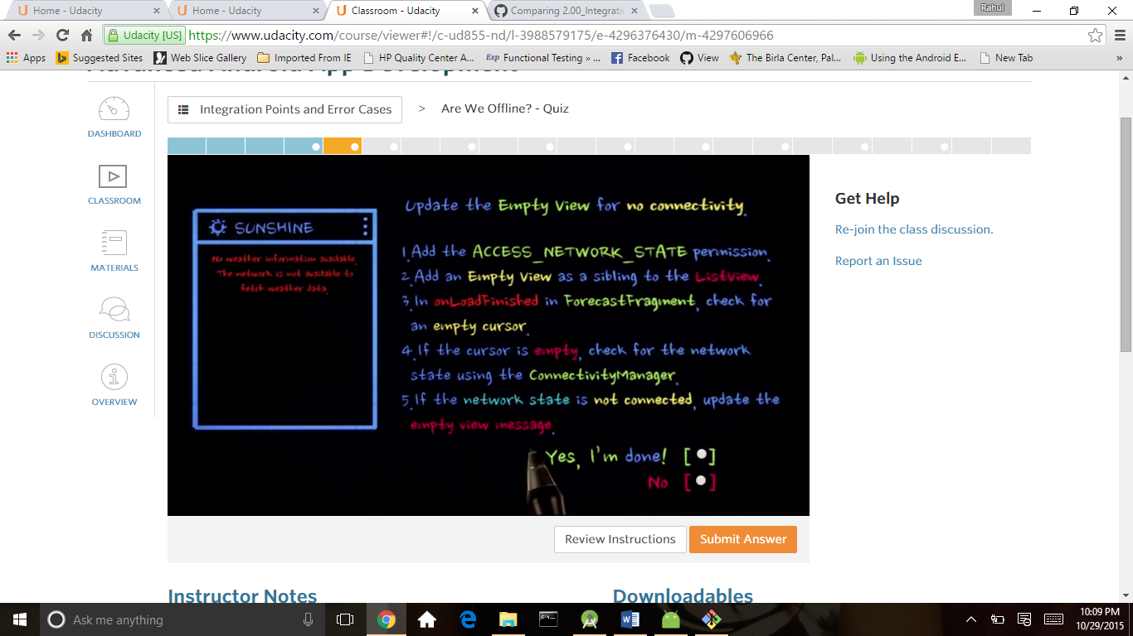

3) if server goes down then we have some corrupted data

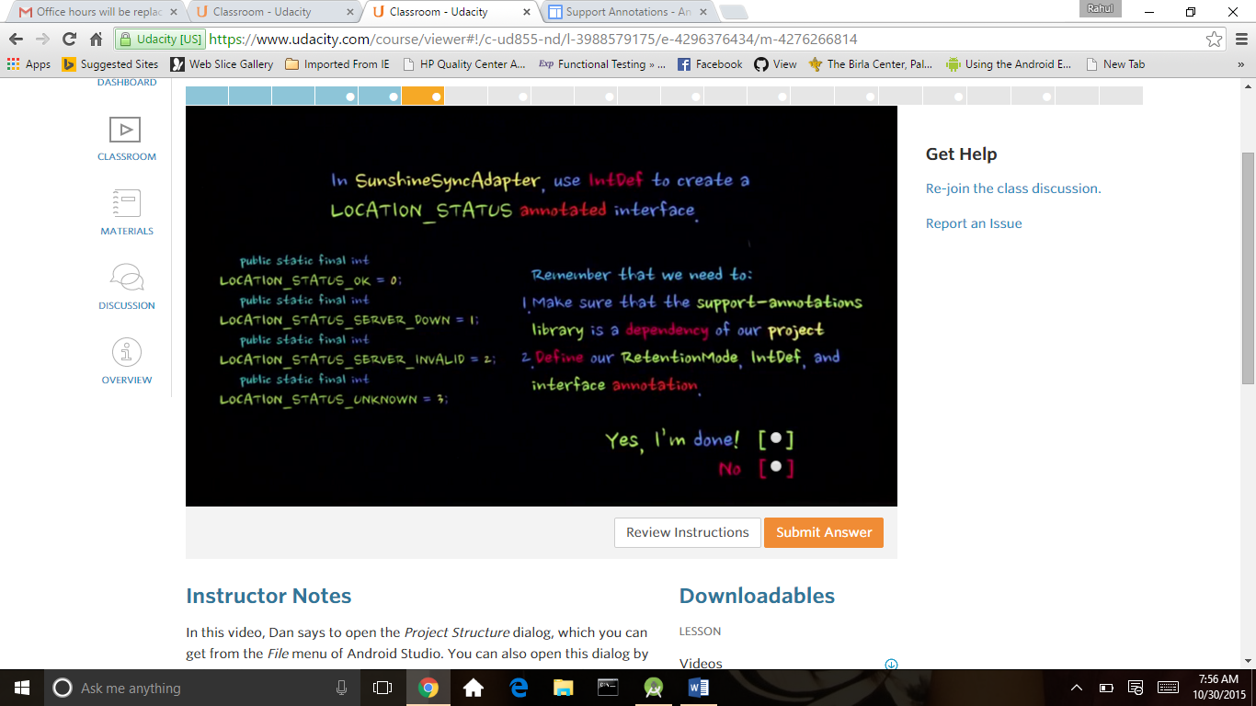

4 some time user enter postel code might be the postel code is same for different country location or may be user enter city name many city have same name so how control this things.

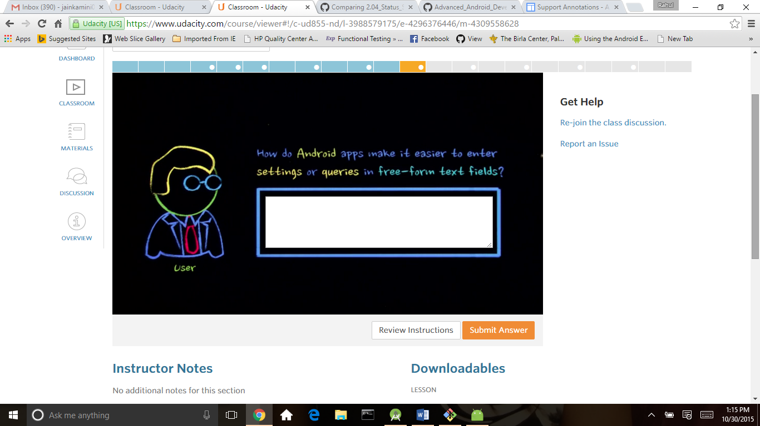

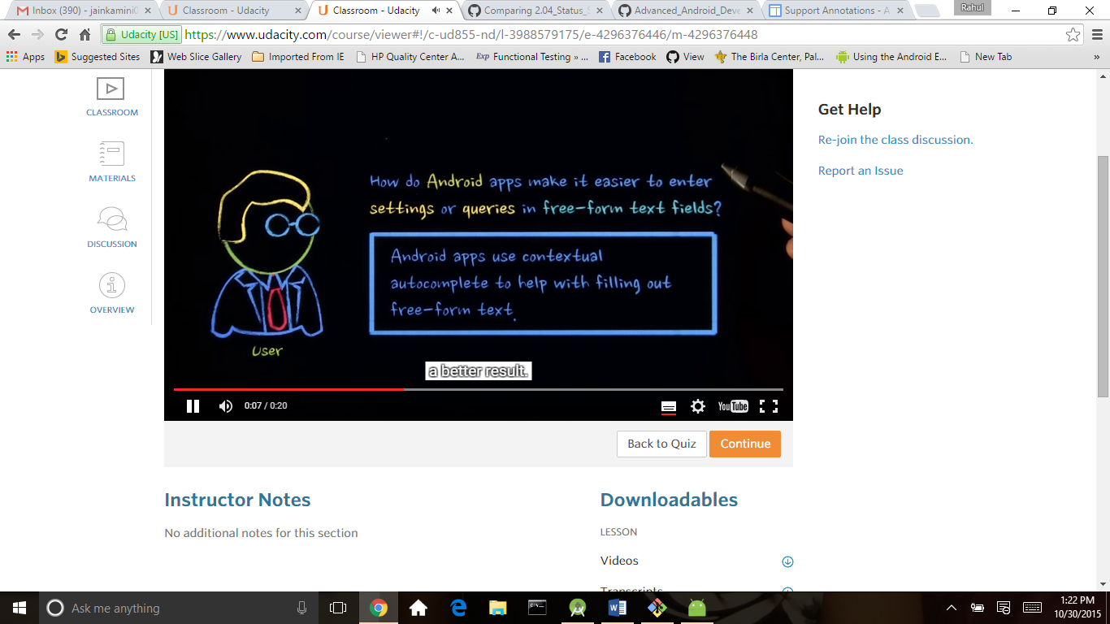

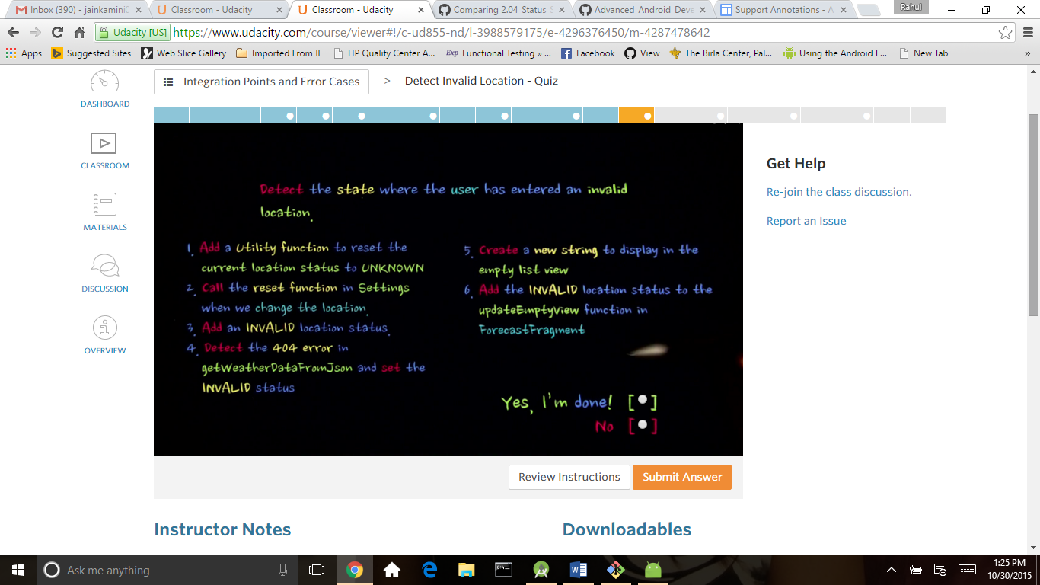

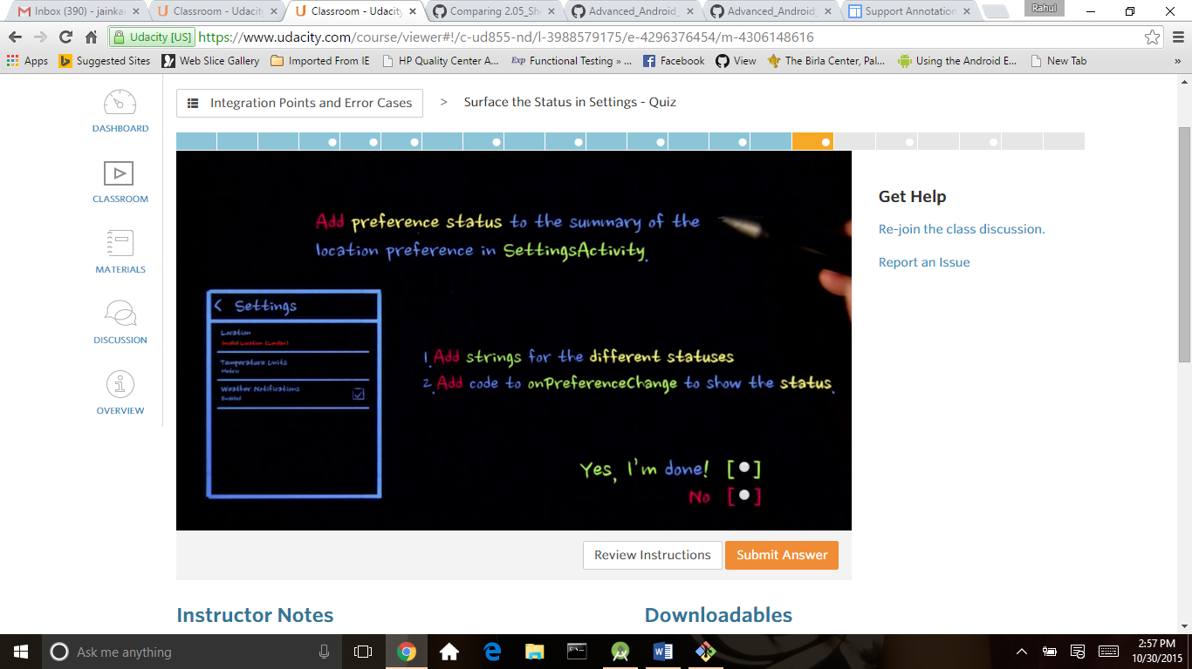Improving Code Inspection with Annotations

<https://developer.android.com/tools/debugging/annotations.html#enum-annotations>

# IntDef

http://developer.android.com/reference/android/support/annotation/IntDef.html

# lint

<https://developer.android.com/tools/help/lint.html>

# Android Studio Overview

https://developer.android.com/tools/studio/index.html#annotations

# Creating a View Class

<http://developer.android.com/training/custom-views/create-view.html>

# DialogPreference

http://developer.android.com/reference/android/preference/DialogPreference.html